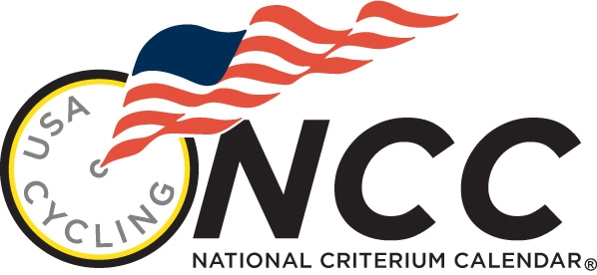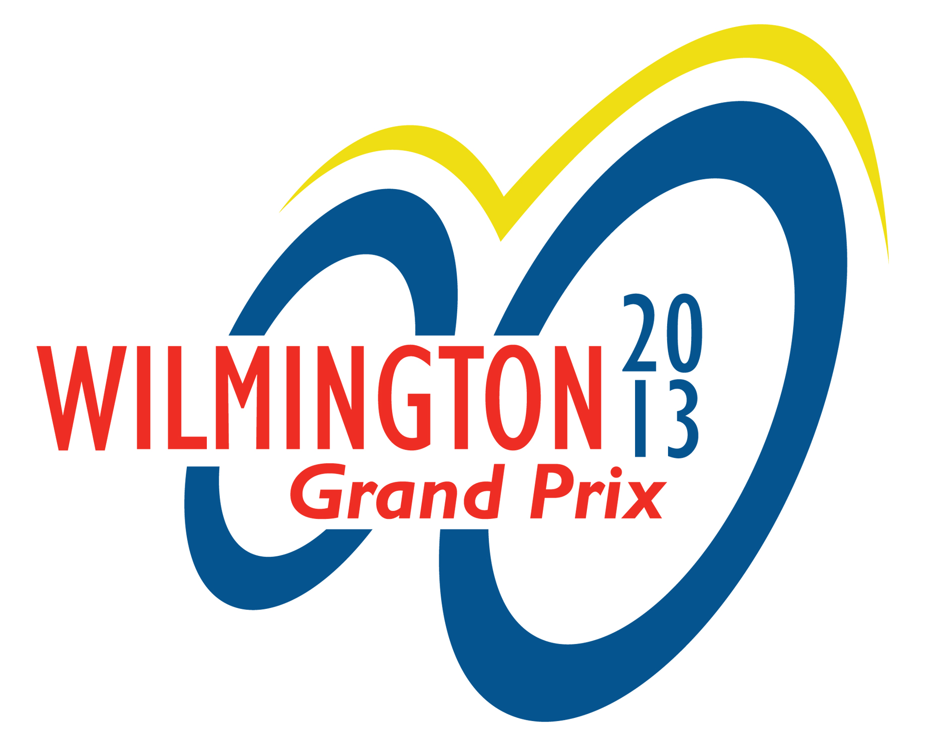

Team TBB/DEEP BLUE Presents

Wilmington Grand Prix

DOWNTOWN WILMINGTON, DELAWARE

USAC National Criterium Calendar Event

MAY 18, 2013

Category Distance Prize/Places* Start Fee
MEN’S 35+ 30 Mins medals / 3 8:00am $35.00
(Cat-5 only)
MEN’S IV 45 Mins $ 1 000.00 / 12 8:45am $35.00

MEN’S MASTERS 45/55 45 Mins $ 1000/12;$500/10 9:45am $35.00
(Cat 1 – 4 only)
MEN’S II/III 60 Mins $ 2,500.00 / 20 10:45pm $40.00
WOMEN’S PRO/1/2 25 Miles $ 7,500.00 / 25 2:15pm $55.00

MEN’S PRO/1 35 Miles $15,000.00 / 25 4:00pm $55.00

MABRA BAR ‘SHOWCASE CRITERIUM’ EVENT

COURSE DESCRIPTION
Start & Finish on the 900 block of Market Street in front of the Grand Opera House
1-mile, 8-corner ‘figure 8’ downtown criterium course with slight rise into the finish.

DIRECTIONS
From north or south: I-95 towards Wilmington Delaware. Take exit 7, route 52 east into the city. Go approximately one-half mile to Rodney Square @ S/F line.

Pre-registration @ www.bikereg.com closes MAY 16th @6pm
Registration fee includes in the entry fee

Sign-in for the Criterium will be held at the Grand Opera House, 818 North Market Street Wilmington DE 19801. Sign-in opens two hours prior to the start of racing, closes 15 minutes prior to event.

For more information on Parking, Lodging, Directions etc go to: www.wilmgrandprix.com

Start & Finish on the 800 block of Market Street in front of the Grand Opera House

ALL USAC RULES APPLY * Held under USAC Event Permit (Pending)

CONTACT INFO:
RANDY INGLIS @ 719-571-0993 or velorandy1@yahoo.com

