
Charm City Cross Technical Guide 2012

Charm City Cross
Saturday September 22 & Sunday September 23, 2012
Druid Hill Park
Baltimore, Maryland USA

The Venue
Druid Hill Park is a beautiful, historic 745 acre urban park established in 1859.

The Event
Charm City Cross in 2012 will mark the 8th annual Charm City Cross and our fourth year as a UCI sanctioned race. This is a Category 2 UCI and USA Cycling cyclo-cross event. The event will be held under UCI regulations and USA Cycling Permit # (Permit Pending). UCI scale of penalties and USAC penalties will apply.

Registration
www.bikereg.com
Registration Fees: $35 for UCI Elite events, $10 for Amateur U19 events, $20 for Elite U19 Men,
$30 for all other events. Lil’ Belgians Free
Online registration closes on Wednesday, September 19th at 11:00pm
There is also a nominal fee to register online with BikeReg.
No mail-in registration.
No Refunds
On Site Late Registration may be available for non-UCI classes, however we urge you to register online to avoid the additional $10 same day registration fee. UCI racers must pre-register.
The registration pavilion will open by 8:00am.

Licensing Requirements
The UCI Elite Men/U23 Men, UCI Elite Women/Master Women 35+/U23 Women must have a current International License. A domestic USAC license is acceptable for all other categories.

Annual and One Day USAC licenses will be available for sale at the registration booth.

NOTE ON RACING AGE: Your racing age is your age as of December 31, 2013 (not 2012).

Note: There will be no separate payout for the U23 Men and U23 Women racing in the UCI categories.

Schedule for both Saturday and Sunday
9:00am 40 minutes Cat 4 Men (field limit 125)
10:00am 45 minutes Cat 1/2/3/4 Masters Men 45+, Cat 1/2/3/4 Masters Men 55+/60+ (field limit 125)
11:00am 40 minutes Cat 3/4 Women, Cat 1/2/3/4 Masters Women 45+, U19 Amateur Men & Women (field limit 125)
12:00pm 45 minutes Cat 1/2/3/4 Masters Men 35+, Elite U19 Men(field limit 125)
1:00pm Lil’ Belgians Kids Race
1:15pm 45 minutes Cat 2/3/4 Men (field limit 125)
2:30pm 40 minutes UCI Elite Women/U23 Women/Master Women 35+ (field limit 125)
3:45pm 60 minutes UCI Elite Men/U23 Men (field limit 125)

Note: For the races with combined fields the 125 field limit is for the COMBINED field, not each individual field.
BikeReg will be set up such that once the limit has been reached for the combined field registration will close for each of the individual fields within that combined field.

The course will be open for inspection and warm-up approximately 15 minutes prior to each event. The officials will make an announcement when the course has been opened for inspection. Warming up on the course during an event is strictly prohibited and will not be tolerated. We suggest you inspect the course at least two slots before your race as you will need to get to the starting grid 15 minutes before your start time for staging.

Course Description
This is a traditional Charm City Cross course looping through historic DRUID HILL PARK.
-Combination of pavement, grass, dirt path, and sand
Saturday course description
The course begins with a long, slightly uphill paved road start with a wide, sweeping left turn onto a wide grass and dirt surface with no sharp turns and plenty of room for passing. After approximately 400m the course funnels into standard width and traverses an off-camber slope to a series of climbing turns. A gradual uphill brings riders to a gently curving sand pit. The sand is ridable, but can become a short run. From there, riders enter a sweeping downhill that leads to a climb up a short hill for the first pass of the two-sided pit. Past the pit the track follows a fast downhill leading to the back-side of the course. This section of the course is characterized by long straight sections, sweeping turns, off-cambers, and a set of stairs up a hill. Another fast, twisting downhill brings riders back to the main section of the course. Riders will be able to carry speed into an uphill that leads to the second pass of the pit and beyond that a natural obstacle that forces a very brief run. Another fast downhill sweeping turn leads to a grinding uphill to a set of planks adjacent to the finish line. Past the barriers riders will have a relatively fast, twisting descent to a series of turns at the bottom of the hill before transitioning onto the road for the finish. The finishing stretch of paved road begins with 75 meters of uphill to a wide right hand turn leading onto the final 125 meters of slightly uphill, wide pavement to the finish line. The course is 2.9km in length with several sections allowing recovery and has either 3 or 4 dismounts per lap. Note: the sand section might be removed for the uci elite races.

Course Map for Saturday

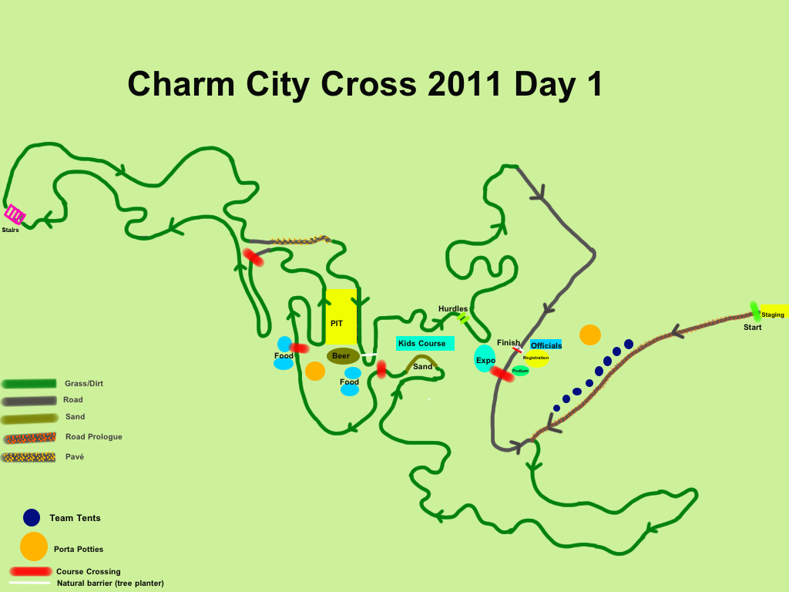

Sunday course description
The course begins with a long, slightly uphill paved road start with a wide, gradual left to right S-bend onto a wide, slightly uphill, grass and dirt surface. The track follows a dirt path for 100m of straight followed by a gradual 180 degree turn into a series of hillside turns leading to the hurdles. Not long after comes a natural obstacle that forces a short run. The remount from the run is at the first entrance of the two-sided pit. After the pit riders will head downhill and across to the back side of the course. Once there the course climbs to the high point of a hillside before twisting down and around a natural bowl and then up to a set of stairs back up the slope. The next section allows some recovery as it is mostly downhill with just a few sweeping turns before returning to the main section of the course for a power climb up to the second pass of the pit. Next up is a short downhill into a sweeping turn that traverses a hillside before climbing up to a ridable sand section. From the sand, the course finishes with a fast straights connected by flowing grassy turns before returning to the pavement near the start for a 200m finishing straight of slightly uphill pavement. The course is 2.8km in length with several sections allowing recovery and has either 3 or 4 dismounts per lap. Note: the sand section might be removed for the uci elite races.

Course Map for Sunday

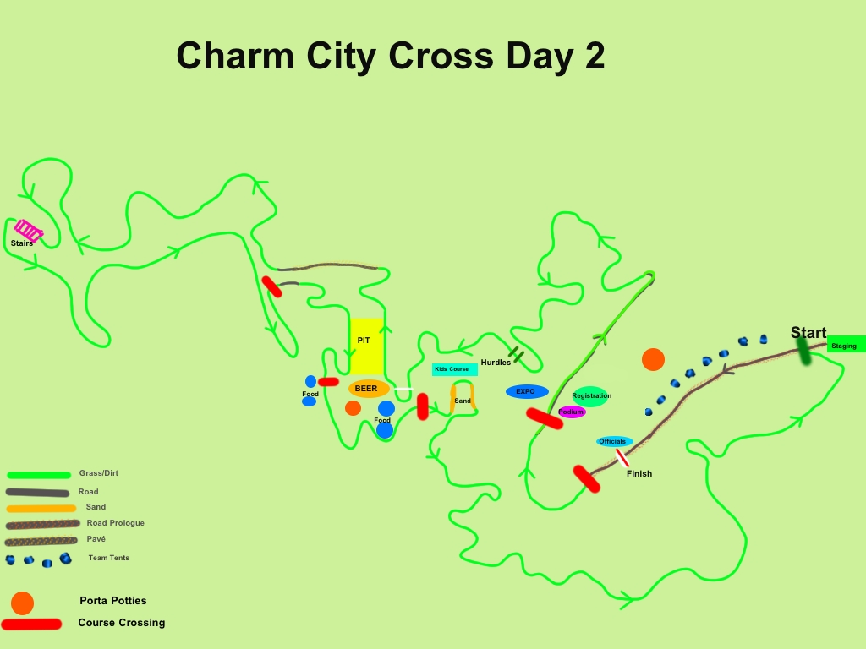

Prize Schedule for Elite Men and Elite Women
Prize Schedule for Men and Women. We reserve the right to increase the prize payouts.

Place | Men $ | Women $
1st | 445 | 445
2nd | 228 | 228
3rd | 150 | 150
4th | 120 | 104
5th | 109 | 91
6th | 104 | 78
7th | 97 | 78
8th | 89 | 78
9th | 85 | 78
10th | 81 | 78
11th | 76 | 39
12th | 61 | 39
13th | 57 | 39
14th | 48 | 39
15th | 33 | 39
16th | 28
17th | 28
18th | 28
19th | 28
20th | 28
21st | 18
22nd | 18
23rd | 18
24th | 18
25th | 18
Total | $2014 ** | $1603

** The Elite Men’s payout amounts are net and reflect the 2% that the organizers are required to deduct for the Council for the Fight Against Doping (CFAD). Note: we are paying above the uci minimum prize for the top 3 elite women so that the prizes for the top 3 women are equal to those of the top 3 men.

UCI Points Schedule – Class 2
Place | Elite Men | Elite Women
1 | 40 | 40
2 | 30 | 30
3 | 20 | 20
4 | 15 | 15
5 | 10 | 10
6 | 8 | 8
7 | 6 | 6
8 | 4 | 4
9 | 2 | 2
10 | 1 | 1

Prize Schedule for the other races
Cat 1/2/3/4 Master Men 35+: $500 (10 deep)
Cat 1/2/3/4 Master Men 45+: $500 (10 Deep)
Cat 1/2/3/4 Master Men 55+: Medals or merch (3 deep)
Cat 1/2/3/4 Master Men 60+: Medals or Merch (3 Deep)
Cat 2/3/4 Men: Merch (8 Deep)
Cat 4 Men: Medals or Merch (8 Deep)
Cat 3/4 Women: Medals or Merch (8 deep)
Cat 1/2/3/4 Master Women 45+: Medals or Merch (3 Deep)
Elite U19 Men: $150 (3 Deep)
Amateur U19 Men: Medals or Merch (3 Deep)
Amateur U19 Women: Medals or Merch (3 Deep)

Start Line Protocol
Racers must report to the holding pen adjacent to the starting grid for staging 15 minutes before the start of their race.

Call-Up Protocol
All racers will be staged sequentially by race number.

Race numbers will be assigned based on the following: UCI points (most recently published), MAC Series points (most recently published), order of registration, late registrants, and promoter’s discretion.

Note: The Cat 4 Men’s race will be staged by order of registration.

Feeding
Note that feeding during competition is generally prohibited. However, if the temperature is above 20 degrees C (68 degrees F), the Chief Commissaire may authorize feeding during a race. If feeding is permitted it must be done in the Pit lane, but is not allowed during the first two and final two laps of the race.
Lapped Riders in UCI Events (UCI Rule 5.1.051): All riders lapped before the final lap must leave the race the next time they cross the finish line. The rider will be given a placing if he or she was lapped more than half way through the race. A rider who is lapped on the final lap shall be stopped at the beginning of the finishing straight line and shall be given a placing on the basis of his or her position. Additionally, Commissaires may pull riders who are behind by more than 80% of the leaders lap time.
Lapped Riders in Non-UCI Events: Lapped riders will finish on the same lap as the leaders. Riders in danger of being lapped must yield to oncoming racers and are not to interfere with their progress or trail behind them.

Pit
There will be one double-sided pit on the course. Only authorized personnel are allowed access to the pit. Pit passes will be distributed at registration to each competitor (one per entrant) in UCI events (Elite Men, Elite Women).

In non-UCI events only those working the pit will be allowed. The pit official will have the authority to remove anyone that is interfering with the proper functioning of the pit.

We will have bike racks in the Pit. These are for racers that are currently racing, not for storing your equipment all day. Please remove your equipment immediately following your race to make room for others.

Equipment
No flat bars or tires wider than 33mm will be allowed in UCI events (Elite Men, Elite Women). Officials will check tires in the holding pen prior to the start of the UCI races.

Anti-Doping
Anti-doping is under the control of USADA in accordance with UCI regulations. The location of the anti-doping area
will be noted on site.

Medical/First Aid
A Medical Doctor and registered EMT will be on site, set up near the registration pavilion.
Closest hospital:
Sinai Hospital
410-601-9000
2401 W Belvedere Ave, Baltimore, MD
Directions to Sinai Hospital:
From downtown Baltimore, take I-83 North (Jones Falls Expressway) to Exit 10, Northern Parkway West. At third traffic signal, take a left onto W. Belvedere Avenue, Sinai Hospital will be on your left.

Directions to Druid Hill Park
You can plug Hanlon Dr. Baltimore, MD 21211 into Google Maps
Directions from points North and West of Baltimore
The directions below are from I-83. You can get to I-83 in the following ways:
From Philly: I-95 to I-695 to I-83 South
From Central PA: I-83 South
From WV: I-70E to I-695N to I-83 South
From I-83 Take exit 7 (west) to Druid Park Lake Drive.
Make a right at the light onto Swann Drive to enter the park, continue on Hanlon Dr.
At the second stop sign, make a left onto Mansion House Drive.
Park on closed road or in designated areas. Do not park on the grass!
Directions from points South of Baltimore
I-95N to Exit 53 I-395N toward ML King Blvd
Continue on ML King Blvd
Turn LEFT on McCulloh St/MD-129
Turn RIGHT at Druid Park Lake Dr.
Turn LEFT at Madison Ave
Continue on Swann Dr
Continue on Hanlon Dr
At the second stop sign, make a left onto Mansion House Drive.
Park on closed roads or in designated areas. Do not park on the grass!

Spectating
Druid Hill Park is a very spectator friendly venue with good sight lines of the entire track from a central location. Most spectators congregate in the area adjacent to the pit, natural barrier (tree planter), and sand. The Lil’ Belgians course, kid’s playground, food vendor area, and beer garden are also right there. Bring the family and enjoy the day. We will have clean port-o-john’s and hand sanitizer adjacent to the Registration/Finish Line area. These will be delivered the morning of the race. There are other port-o-john’s scattered around the Park but those will not be clean and we do not recommend using them.

Lodging
When visiting Baltimore we recommend staying at the Intercontinental Harbor Court hotel
for classic European style on the Inner Harbor.

Event Staff
Event Organizer: Kristopher Auer
Organizer Address: 2707 Hampden Ave., Baltimore, MD 21211 USA
Technical Director: Chris Nystrom
Media Director: Marc Vettori
Registration Director: Suzy Gerlak
Results Director: Norman Brach
Sponsoring Club: Charm City Cycling (C3-Athletes Serving Athletes)
With assistance from: Adventures For The Cure, DCCofD
Announcer: Shawn Downing

Commissaires Panel
UCI Chief Commissaire & Chief Referee: Phil Miller
Chief Judge: tbd
Judge: tbd
Judge: tbd
Secretary: tbd
Referee: tbd
Referee: tbd
Referee: tbd

Event History
Elite Champions
2005: Ryan Leech & Sami Fournier
2006: Ryan Leech & Deidre Winfield
2007: Davide Frattini & Carolyn Popovic
2008: Michael Gallagher & Laura Van Gilder
2009: Davide Frattini & Laura Van Gilder
2010: Day 1: Davide Frattini & Laura Van Gilder
2010: Day 2: Davide Frattini & Laura Van Gilder
2011: day 1: Tom van den bosch & Helen wyman
2011: day 2: ian field & Helen wyman

